Question 4: Asymmetry Information in Markets
Name
Institution
Date

Question 4: Asymmetry Information in Markets
In the contemporary scenario, the economic literature underscores the relevance of asymmetric information in our markets. Top-notch studies have pointed out that asymmetric information bolsters our understanding of a wide range of marketing practices. It focuses on situations in which there is unequal knowledge amid seller and buyer. Herein, there is an unpredictable market failure since the correct price cannot be established as per the law of supply and demand (Attar & d'Aspremont, 2018). This paper discusses how the asymmetric information in markets can potentially cause a ‘lemons problem.’
In every market, there is a hypothesis that buyers and sellers have adequate understanding of every good for sale in a market, more so their quality. Borrowing from the market forces, the buyer's willingness to meet the product's price depends on knowing the value of the product to themselves (Zavolokina, Miscione, & Schwabe, 2020). However, by overestimating the product, they might end up purchasing it at a price that exceeds their readiness to pay the product since its quality is known. This situation would impact by lowering the total surplus, causing lack of market efficiency. We anticipate the sellers of goods to be more informed about the product than the buyer, though this situation does not apply in all cases, thus providing adequate room to illustrate the 'lemon problem'.
For example, assume that two types of second-hand cars are available for sale. One car is of high quality, and the other is of low quality. Given that both sellers and prospective buyers can accurately define and distinguish the type of each car, there exist two markets in this situation, as expressed in figure 1.0. In part (i), S_{H} and D_{H} signify the supply curve for highly-quality cars and demand curves, respectively. In part (ii) S_{L} and D_{L} represent the supply and demand curves for low-quality cars. In all situations, the S_{H} remains to the left of S_{L} simply because the sellers of the high-quality cars are pretty sure about the quality of the car, and hence price must be tagged higher. Also, the affiliated D_{H} remains higher than D_{L} because buyers are convinced and willing to spend more funds to secure a high-quality car that meets their expectations and ambitions. As evident from the figure, the high-quality cars market price remains $10000 and $5000 for low-quality cars and about 50000 cars in each market.
In essence, the second-hand car owner has more information about the car, unlike the prospective buyer. Buyers can only realize the quality of the car after buying and driving it for a while. Moreover, consider a situation where the seller understands the ultimate quality of cars more than the buyers do. In this case, buyers may be 50% confident that the car will be of high quality since both parties have a thorough know-how of the quality of each type of car sold. Thus, the prospective buyers can rank all cars as 'medium quality since there are equal chances of securing any kind of car. The medium quality (DM) cars are likely to sell at $7500, selling few high-quality cars and many low-quality cars.

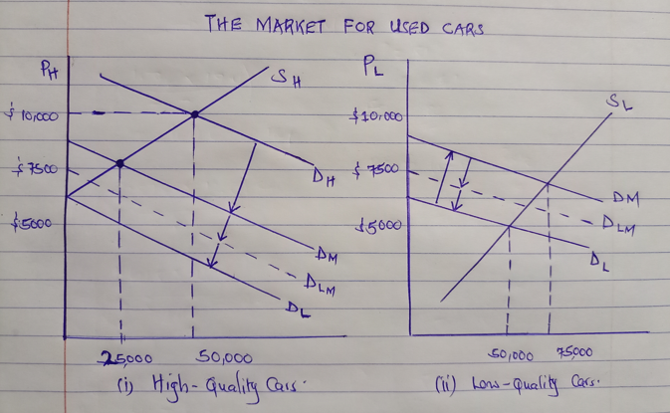
Fig 1.0
Analytically, when buyers start to know that most cars sold are low quality, the affiliated demand shifts to D_{LM}. A clear indication that cars are believed to be of low or medium quality. Critically, mixing high quality and low-quality cars would elevate the demand curve further to the left, increasing demand for low-quality cars. The demand curve is likely to obey the shifts until only low-quality vehicles are sold, making the market price too low to sell high-quality cars since customers will assume that all cars in the market are of low quality. Therefore, the only demand curve will remain D_{L}. When the situation persists, the market may record an equilibrium alongside a price that paves the way for high-quality cars. Herein, one gets a clear understanding of why brand new cars that one knows in perfect condition should cost less than their initial cost. With close reference to the concept of asymmetric information, second-hand goods tend to deteriorate the market for high-quality goods, posing the lemons problem, an ideal source of market failure (Bauer, Zavolokina, & Schwabe, 2020).
Current literature shows that the market for used cars in the UK has been an affluent area of research for economists interested in information economics (Emons & Sheldon, 2009). The concept of adverse selection is quite evident in the UK used-car market. As such, adverse selections mainly occur when precious attributes of a market such as quality products, sellers, and buyers exit due to asymmetric information. Therefore, seller and buyer may not stand a chance to make beneficial transactions. The presence of highly informed agents exploits the advantages of a transaction, causing market failure. Bauer et al. (2020) pointed out that over 700,000 buyers in the UK have experienced unresolved issues with second-hand car purchases for years. In 2019, the average age of vehicle use in the UK stood at 7.9 years. Antique cars tend to be full of faults, increasing the risks facing a potential buyer. The owner of lemons has more information about their cars than the prospective buyer. They utilize this opportunity to sell such a car at the prevailing price since it is higher than its actual value, causing adverse selection and lemons problem as well.
In reflection, the lemon problem in the UK’s used car market can be controlled by issuing warranties and guarantees on used cars and ensure log service records. Baumann, Zavolokina, & Schwabe (2021) provided that rigorous testing and use of consumer reviews of all used cars sold would keep buyers informed. High standards should be maintained through the registrar of trusted dealers. Effective control measures would boost the quality of used cars in the market and increase price in the long-run. Increased market prices will encourage sellers of good vehicles to sell their cars, thus countering adverse selection and lemon problem.

References
Attar, A., & d’Aspremont, C. (2018). Trading under asymmetric information: Positive and normative implications. In Handbook of Game Theory and Industrial Organization, Volume I. Edward Elgar Publishing.
Bauer, I., Zavolokina, L., & Schwabe, G. (2020). Is there a market for trusted car data? Electronic Markets, 30(2), 211-225.
Baumann, J., Zavolokina, L., & Schwabe, G. (2021). Dealers of Peaches and Lemons: How Can Used Car Dealers Use Trusted Car Data to Improve their Value Proposition? University of Zurich.
Emons, W., & Sheldon, G. (2009). The market for used cars: new evidence of the lemons phenomenon. Applied Economics, 41(22), 2867-2885.
Zavolokina, L., Miscione, G., & Schwabe, G. (2020). Buyers of ‘lemons’: How can a blockchain platform address buyers’ needs in the market for ‘lemons’? Electronic Markets, 30(2), 227-239.

